Emotion Detection

Bansil Patel  
Artificial Intelligence and Machine Learning  
Lambton CollegeToronto, Canada  
[c0902873@mylambton.ca](mailto:c0902873@mylambton.ca)  
  
Harsh Mohile  
Artificial Intelligence and Machine Learning  
Lambton CollegeToronto, Canada  
[c0912872@mylambton.ca](mailto:c0912872@mylambton.ca)  
  
Meet Patel  
Artificial Intelligence and Machine Learning  
Lambton CollegeToronto, Canada  
[c0910378@mylambton.ca](mailto:c0910378@mylambton.ca)  
  
Rachit Bhatt  
Artificial Intelligence and Machine Learning  
Lambton CollegeToronto, Canada  
[c0902810@mylambton.ca](mailto:c0902810@mylambton.ca)

*Abstract*—This article is an emotion detection system for analyzing the customer support interactions in order to understand their customer sentiment. By leveraging NLP and ML, the system aims to understand and extract emotions like urgency, satisfaction, and frustration, delivering actionable insights for improving the customer service for enhancing satisfaction [1], enabling companies to enhance their service quality, provide actionable insights to customer support teams, and improve customer satisfaction.

Keywords—emotion detection, customer support, nlp, machine learning, sentiment analysis, data privacy, real-time monitoring, customer satisfaction.

# Introduction

This open-source project aims to analyze the customer emotions considering the most crucial in the customer support industry. The main reason for this is often the emotion impacts customer satisfaction and retention rates [2]. The emotion detection models can automate this vague process, allowing businesses to gain handful insights into customer sentiment and to tailor responses accordingly. The main agenda of this project is to develop an NLP-based solution, applying DNN for efficient outcome, extracting emotions in text-based customer support interactions [3]. As an outcome of this project, the support teams could proactively address the customer concerns, embracing the customers positively [4].

# Motivation

* Avoid implementing computationally expensive models as these may result in out-of-memory errors or increase running time.
* Try various models and experiment with various parameters to achieve the best possible output.
* Apply a wide variety of experiments as a team, performance, and good accuracy in order to choose the best model which is capable of pre-processing and model features.

# Methodology

This process of this project emphasizes a structured methodology to follow that involves the following steps using the scrum-based agile methodology which includes requirement gathering, designing, development, testing, deployment, and maintenance:

## Data Collection

* The initial approach would be to use the online resource to get the dataset such as Kaggle Repository [9].
* The data collected would be in a form of CSV format.

**Data Dimension:** 211225 (211 K) x 31

## Data Card

1. Dataset Description

| Sr. No. | Dataset – go_emotions_dataset.csv | | |
| --- | --- | --- | --- |
| Description | Column | Type |
| 1. | ID of record. | id | str |
| 2. | Text containing sentiment. | text | str |
| 3. | Example of unclear sentiment. | example_very_unclear | bool |
| 4. | Emotion – Admiration | admiration | int |
| 5. | Emotion – Amusement | amusement | int |
| 7. | Emotion – Anger | anger | int |
| 8. | Emotion – Annoyance | annoyance | int |
| 9. | Emotion – Approval | approval | int |
| 10. | Emotion – Caring | caring | int |
| 11. | Emotion – Confusion | confusion | int |
| 12. | Emotion – Desire | desire | int |
| 13. | Emotion – Dissappointment | disappointment | int |
| 14. | Emotion – Disgust | disgust | int |
| 15. | Emotion – Embrassment | embrrassment | int |
| 16. | Emotion – Excitement | excitment | int |
| 17. | Emotion – Fear | fear | int |
| 18. | Emotion – Gratitude | gratitude | int |
| 19. | Emotion – Grief | grief | int |
| 20. | Emotion – Joy | joy | int |
| 21. | Emotion – Love | love | int |
| 22. | Emotion – Nervousness | nervousness | int |
| 23. | Emotion – Optimism | optimism | Int |
| 24. | Emotion – Pride | pride | int |
| 25. | Emotion – Realization | realization | int |
| 26. | Emotion – Relief | relief | int |
| 27. | Emotion – Remorse | remorse | int |
| 28. | Emotion – Sadness | sadness | int |
| 29. | Emotion – Surprise | surprise | int |
| 30. | Emotion – Neutral | neutral | int |

## Data Cleaning

* The data might have some characteristics that would not be useful for the analysis and predictions will be truncated.
* The features engineering will be applied in case of reducing complexity, poor results, or need of chosen features.
* To filter the textual data, the text will be tokenized followed by stemming and noise removal.
* The tokens are divided into vectors and removed the stopwords along with Label-Encoding.

Identify applicable funding agency here. If none, delete this text box.

## Emotion Detection Modeling

* Various machine learning models such as SVM and Naïve Bayes will be applied along with LSTM and CNN and RNN as DNN.
* The hyperparameter tuning will be performed after the results of each model individually but may not for all.

**Hyperparameter Tuning Parameters:**

* **Learning Rate:** Rate of learning to get rid of the vanishing gradient problem; our LR = 0.001.
* **Optimizer:** Optimizes the app; our optimizer = **Adam**.
* **Early Stopping:** Stops the neural network to run more epochs based on the loss of the data detected while training to save the resources.
* **Patience:** Process of letting the epochs run if the early stopping parameter is not satisfactorily increasing/decreasing. We have used **5** as patience.

**Models:**

Weaker Accuracy in initial epochs.

* Initially, when the model was trained with some random values for train-test split and a few parameters for hyper parameters, the model performed very low.

Weaker Accuracy in initial epochs.

* After finetuning the model, the accuracy increased by 12% overall with better scores on average.

Training Loss and Accuracy Comparison Chart

* The training loss started decreasing while the accuracy increases.
* Unfortunately, the system was not that good enough.

**Using LSTM:**

Training Loss and Accuracy Comparison Chart

* The accuracy of validation increased a little compared to not much in the previous run.

**Applying BiLSTM:**



Epoch details of BiLSTM.

* BiLSTM in this project is used but was not as beneficial at the end.

Epoch visuals of BiLSTM.

* The loss decreased gradually with an increase in the accuracy after applying tuning on BiLSTM.

## Data Visualization

A plethora of interactive and static visualizations were designed to explore the relationships between various metrics:

Group-Based Emotions

Group-Based Emotion Count

Unclear Labels Count

Wordcloud

Most Frequent Words

Google Emotions on Text for Positive Emotions

Google Emotions on Text for Negative Emotions

Grouping of Emotions

Emotion Category Counts

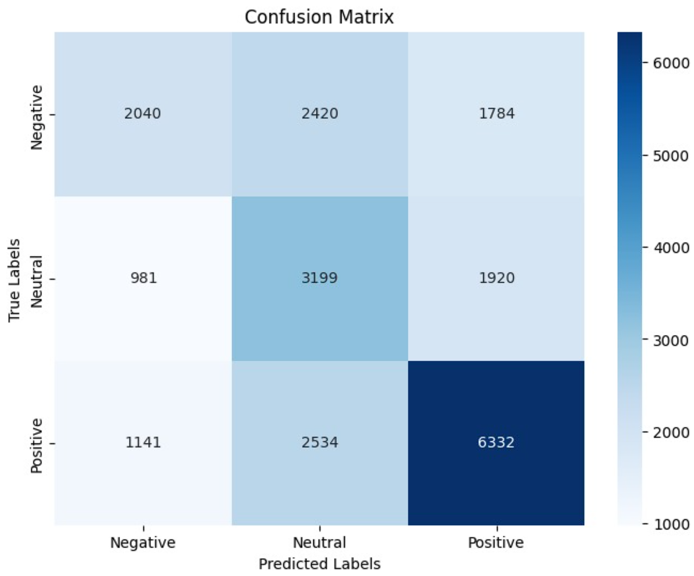

Confusion Matrix – LSTM + GRU

Emotions Count for Each Group

## Deployment

Although the deployment is not necessary, if the milestones are not extended, a web-based user interface will be designed for interactive emotion detection based on what user types.

The deployment is done initially by creating an independent model that could execute without re-training; exported using pickle and keras (h5). One of these model file could be easily useful for predicting the emotion from a given text.

In order to make this application accessible to anybody, we have hosted the app locally using streamlet and Flask.

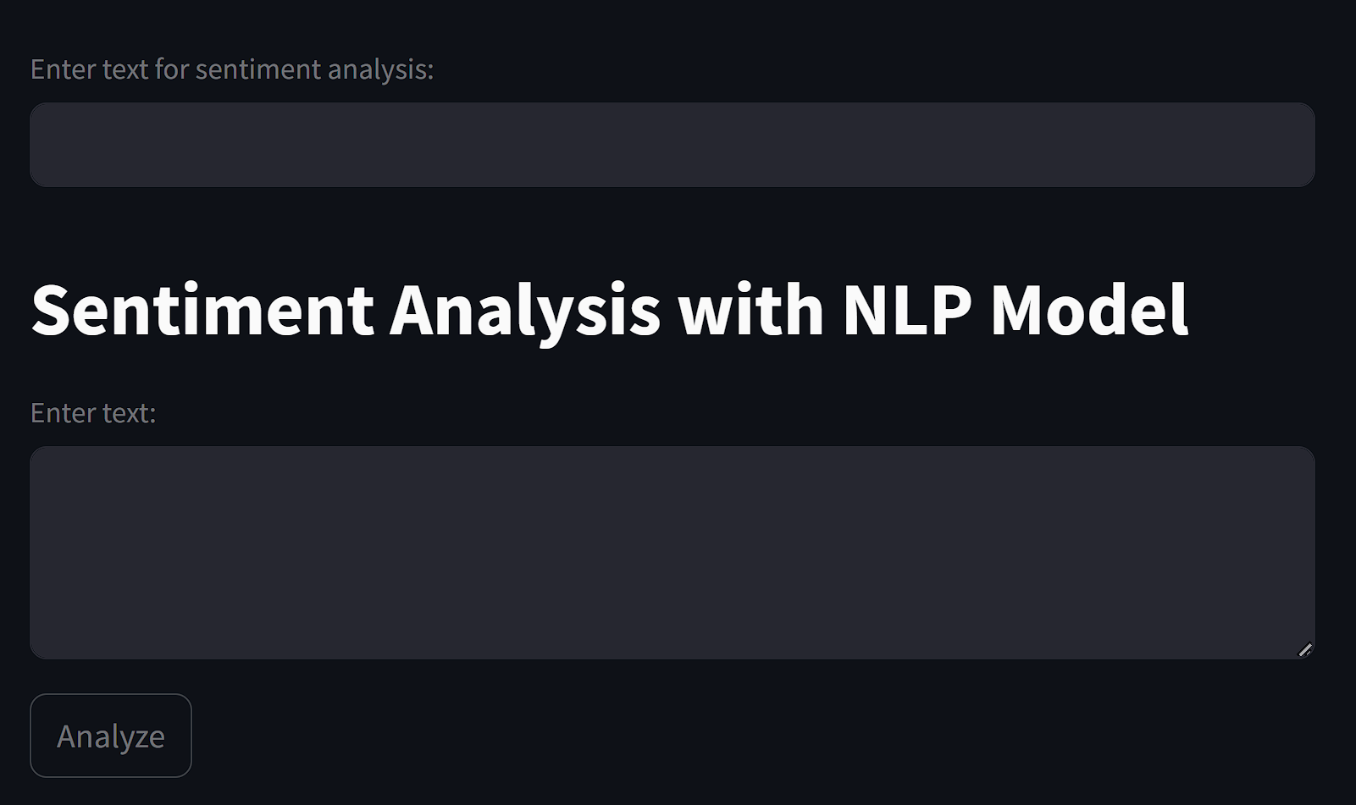

Deployed using Streamleat

# Challenges

The following are a few challenges that we might face while performing this project, both technical and non-technical:

* **Data Privacy:** Protecting the sensitive customer data given the support interactions is crucial.
* **Data Imbalance:** Dataset may contain false representation of emotions; hence, data cleansing would be debatable to proceed to overcome oversampling and under-sampling and use synthetic data generation to address this issue.
* **Model Accuracy:** Achieving higher accuracy and good metrics has always been a challenge, especially in the complex conversations where context is important to know.

# Project Timeline

1. Project Timeline

| Sr. No. | Details | |
| --- | --- | --- |
| Phase | Time |
| 1. | Data Collection | Week 1 |
| 2. | Data Preprocessing | Week 1 |
| 3. | Model Training & Testing | Week 2-3 |
| 4. | Model Evaluation & Refinement | Week 3-4 |
| 5. | Deployment | Week 5 |

# Conclusion

Facilitating emotion detection in customer support conversations brings valuable feedback to the representative and well as the business when interacting and analyzing the services. This project provides valuable insights that will improve the service quality and customer satisfaction. With the help of NLP and DNN, businesses could gain a deeper understanding of customer emotions, proactively address concerns, and enhance their overall support. Such a tool brings maintaining a positive brand image and driving customer loyalty in competitive markets [8].

##### References

1. F. Provost and T. Fawcett (2013). O’Reilly Media. *Data Science for Business: What You Need to Know about Data Mining and Data-Analytic Thinking.*
2. C. O. de Montjoye et al. (2021). ACM Computing Surveys. *Privacy in the Age of Big Data: Exploring the Current State of Affairs and Addressing Emerging Challenges*, vol. 53, no. 3, pp. 1-36, 2021*.*
3. P. Ekman (1992). Cognition and Emotion. *An argument for basic emotions*, vol. 6, no. 3-4, pp. 169-200, 1992*.*
4. R. Plutchik (2001). American Scientist. *The nature of emotions*, vol. 89, pp. 344-350, 2001*.*
5. M. Mohri, A. Rostamizadeh, A. Talwalkar (2018). MIT Press. *Foundations of Machine Learning*, 2018*.*
6. Y. Zhang, B. Wallace (2018). IEEE Transactions on Neural Networks and Learning Systems. *A Sensitivity Analysis of (and Practitioners’ Guide to) Convolutional Neural Networks for Sentence Classification*, vol. 29, no. 2, pp. 289-297, 2018*.*
7. N. V. Chawla et al. (2002). Journal of Artifical Intelligence Research. *SMOTE: Synthetic Minority Over-sampling Technique*, vol. 16, pp. 321-357, 2002*.*
8. G. H. John, R. Kohavi, K. Pfleger. *Proceedings of the Eleventh Internaltional Conference on Machine Learning*. Irrelevant Features and the Subset Selection Problem, pp. 121-129, 1994.
9. *Kaggle Dataset. Online.*